Bookworm.com
Business Requirement Document

V 1.2

PREPARED BY | Jayant Ponkshe
DATE | 10-Oct-25

Document Control:

VERSION | AUTHOR | DATE | CHANGE DESCRIPTION | APPROVER & DATE
0.01D | Jayant Ponkshe | 18-Mar-18 | Initial Draft
1.0 | Jayant Ponkshe | 25-Mar-10 | Final Doc
1.1 | Jayant Ponkshe | 20-May-18 | Final doc after changes
1.2 | Jayant Ponkshe | 10-Oct-25 | To introduce Excel data upload

Table of Contents
1. Introduction 4
1.1. Purpose 4
1.2. Scope 4
1.2.1. In-Scope 4
1.2.2. Out of Scope 4
2. Summary of Requirements 5
3. Detailed Requirements 6
4. Home Page 7
4.1. Top Menu Bar 7
4.2. Home Page Functionality 9
5. Category Page 10
5.1. Category Page Functionality 10
6. Lending Library 12
7. Rent-a-Book 13
8. Item Description Page 14
9. My Shelf 16
10. My Library Page 17
11. Registration Page 17
12. Invoice Page 18
13. Miscellaneous Functionality 20
13.1. Revenue Distribution 20
13.2. Excel data upload 21
14. Admin Panel Functionality 22
15. Point Of Contact 22

Introduction

Bookworm is newly founded organization founded by group of literature & performing art lovers. Bookworm is based on the concept of virtual bookshop, which will allow user to buy, store, & read books online. Further, it will not just restrict itself to books but also it will showcase music albums, films (short films, documentaries etc.).

After various brain storming sessions the concept is finalized and Bookworm is now in process of developing an application that will cater the needs of Bookworm’s virtual shop.

Purpose
The purpose of this Business Requirement Document (BRD) is to define and document a complete and accurate description of the functional & non-functional requirements of the application to be developed.

The application will be a web-based system that will be hosted as “Bookworm.com”.

Currently Bookworm is considering many categories that can be sold virtually. Such as Books, Music, films etc. All such products would be only available in digital formats. No physical delivery is expected (like printed books, or DVD, VCD ect.).

Scope

In-Scope
All requirements specified in this document shall be considered as “Mandatory” or “Must to have” unless specified otherwise. All such requirements and also such requirements not documented but may be needed to incorporate to fulfil mandatory requirements shall be in scope of this project. All such requirements are required in order for the product to be considered complete.

Out of Scope
Requirements specified as “Optional” or “Nice to have” may be considered as out of scope of this project. All such requirements are not required for the product to be considered as complete, however if feasible the product shall include these requirements.

All requirements shall be considered mandatory unless specified otherwise.

Summary of Requirements
The system should allow user to register himself/herself. The system shall allow all register members to browse all products and buy them. All purchased items will be added to user’s shelf. The system should allow user to access these products from shelf (i.e to read books and/or play the audio/video)

The system shall allow members to maintain his/her personal shelf. The shelf may contain any product that he/she may purchase. The shelf would able to store any number of products category wise (i.e. eBooks, Audio-Books, Videos) .
The system should allow member to view/read the product from shelf that he/she may wants to.

Further the system should provide functionality for members who wish to avail the product for limited period usage. In this case users will not be purchasing the product but renting the product. Also, system will have library functionality thru which members can lend the books as per library package purchased. This concept detailed in My Library section.

Bookworm may give some loyalty points to its members on purchase of any product. These points may vary from category to category and/or product to product. These points can be redeemed against renting or purchasing amount. System should maintain the ledger of the same. However this functionality is not mandatory. English shall be default language.

To make the system “maintenance free”, the system should be dynamic and entire functionality should be database driven.

The system should be flexible and easy to maintain. It is expected that no hard-coding to be used and entire site should be database driven. All images, messages, labels, text, information etc. that would appear on any of the page should be manage thru database. The system should capable to handle most popular (if not all) A/V file types (for e.g. JPEG, JPG, MPEGs, DAT, VBO, Showcase, MP3+, WAV etc), and PDF. The system should provide user interface to maintain database tables.

After every purchase and/or rental / lending transaction the system should calculate the royalty of each beneficiaries as per percentage defined for that product.

The system should provide multilingual functionality. However, to begin with, English shall be default language. Hence system should be flexible to adopt any additional language without any change.

The system should be compatible with IE, Mozilla Firefox, and Chrome.

Detailed Requirements
Further sections describes the detailed functional requirements. It also depicts the navigational flow of various web pages that are required to fulfil these requirements.

The diagram of various web pages given here are for illustration purpose only. It is just to give an idea of navigation flow and what kind of content may appear on each page. Actual web page look-n-feel will be decided later by mutual understanding. However, the content and requirements should be fulfilled thru these pages will remain same.

Home Page
Home page will allow user to sign-on by providing fields to enter user-id and password.

On successful sign-on, appropriate welcome message will appear and “My shelf” “My Library”, ‘My Account”,” buttons will be enabled. Also on successful sign-on “Sign-off” should appear in place of “Sign-on”.

Home page will display icons (thumbnails) of each Product category (such as eBook, Audio book, Music, Videos feature products, Most popular (or best seller) products. On click of any of the category’s thumbnail the system will display category page of respective category. Please refer “Category Page” Section.

Refer Diagram 4D-1 for Home page look-n-feel.

Top Menu Bar
The Top menu bar will have “Home”, "Products", "Lending Library", “My shelf”, “My Library, ‘My Account”, “About us”, “Contact us”, and “Feedback” buttons. The respective button will be disabled when user is on that page. The navigation from each of these buttons is as follows –

Home: This button will bring user to Home page

Products: This will have submenu in which all product categories (eBook, Music, Videos etc) will appear. System will display respective Category page on click of any of these category. This is another way by which user can navigate to page of desired category.

Lending Library: This button too should have submenu similar to "Products" button. Functionality of this button will be same as "Products" button.

My Shelf: This button will be enabled only on successful sign-on. This button will take user to “My Shelf” page. All purchased products will be available for user in this.

My Library: This button will be enabled only on successful sign-on. This button will take user to “My Library” page. All rented and/or lent products will be available for user in this.

My Account: This button will be enabled only on successful sign-on. This will have sub-menu with following options: (Not Mandatory)
  - Edit Profile
  - Purchase History
  - My loyalty points

About Us: This page will provide general information about the company. (Not Mandatory)

Contact Us: This will display appropriate mail-ids and contact details. (Not Mandatory)

Feedback: This link will take user to Feedback page where user will able to give feedback. (Not Mandatory)

Diagram 4D-1 Home Page

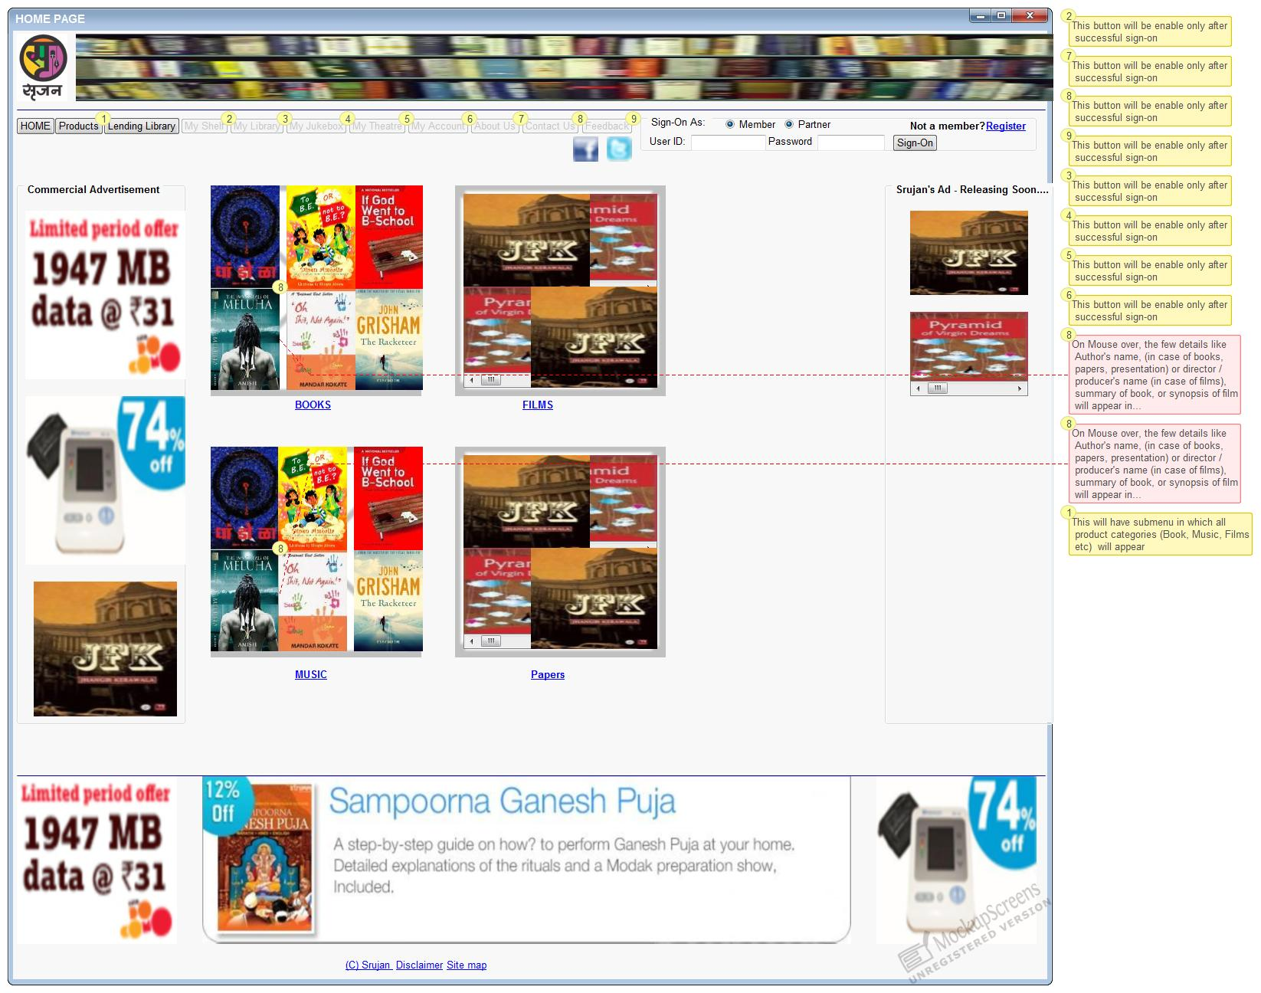

Home Page Functionality
To register as a member, a link “Register” should be provided next to Sign-on. This link will take user to “Registration Page” The same is explained in “Registration Page section”.

“My Shelf” is an exclusive area for registered member. This button will be available only for registered member after successful sign-on. The functionality of this page is detailed in “My Shelf Page section”.

“My Library” is an area for registered members or library members. It will display all items that member has lent / rented for limited period. The functionality of this page detailed in “My Library Page section”.

“My Account” will have submenu with following options. (Functionality is not mandatory)

Edit Profile: This will allow member to change his/her details including password. This will be done using “Registration page”.

Category Page
Please refer Diagram 5D-2 for “Category Page”. This page will display products from selected category. All products will be shown its sub-category wise (if any). (for ex. all books will be shown category wise like Novel, Short Stories, Poetry, sci-fi, Romance, Psychology, Thriller etc.). The same will be applied to other products too.

Top menu bar will have one more button “Lending Library”. This button will take member to lending library page, where member can lent any product. The functionality of lending library is similar to Category page functionality. The same is describe in "Lending Library session".

Category Page Functionality
The system should display all items from selected category. The items should be displayed sub-category wise (if any). For ex. all items from eBook category may be displayed on its sub category wise (Novel, Short Stories, Poetry, sci-fi, Romance, Psychology, Thriller etc and items from Music category may be displayed by its sub-category wise such as Indian classical, Western classical, pop, Jaaz, etc.

The system should provide search option to search product on its title, and/or partner’s name, or genre or on keyword (tags). . The search result should display resulting products in the respective category but in similar fashion.

Each item of any product type will be displayed as an icon. The title of each item and its cost will be displayed underneath.

Purchase can be made only on successful sign-on. No purchase is allowed as a “guest”.

On click items icon, the page should appear in different tab with item description. The same is explained in “Item Description Page section”.

While user purchases products, the number of items added in cart should be displayed above cart icon. Similarly the total amount of purchased items should be displayed next to it.

Checkout link will calculate the total bill amount and will take user to Invoice page. Functionality of invoice page is described in “Invoice Page Section”.

Diagram 5D-2 Category Page

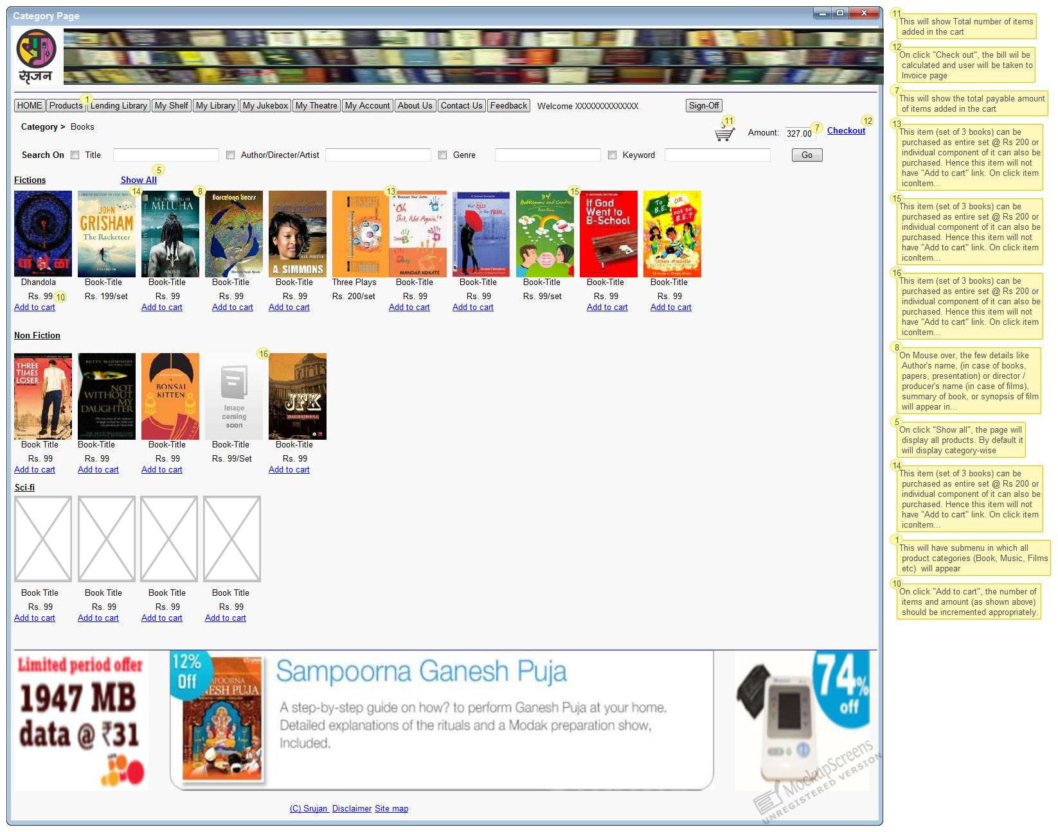

Lending Library
The Category page functionality shall be reused for Lending Library section. This is similar to lending library (of physical books) concept that will allow user to lend a defined number of books for reading within valid period of the said package.

To avail this facility member should purchase library package. Library package will be for certain valid period and allow users to lend defined number of books within that period. For ex. Library package for 30 days for 12 books at price say Rs 120. Any member purchase this package will allow to lend any 12 books from Library section within 30 days from the date of purchase of the package. User can chose all 12 books at a time or as he/she wishes. However package will be void once 12 books are chosen by user or after 30 days. All these books should disappear from his “My Library” section after valid period is over.

The Page will be similar to Category Page. Only difference would be that each item will have “Lend” link instead of “Add to card”. Also to be noted only those products will be displayed in this section which are allowed to be in library section.

Rest of the functionality (like showing Item description page, Checkout, etc.) will be similar to Category page functionality.

Currently only selected eBooks will be allowed to be in Library section. Please note every eBook may not be available for lending or renting.

This is nice-to-have requirement (Not mandatory but nice to have). However either of “Lending Library” or “Rent-a-book” functionality has to be provided.

Rent-a-Book
For this section too the Category page functionality shall be reused like Lending Library section. This is similar to lending library concept that will allow user to rent a product for any number of days by paying rent on daily basis.

The Page will be similar to Category Page. Only difference would be that each item will have “Rent” link instead of “Add to card”. Also to be noted only those products will be displayed in this section which are allowed to be in rent section. On click of Rent, system will show daily rent and allow user to feed number of days he /she wants to rent. After accepting No of days system will calculate total rent and ask user to go ahead.

For ex. For a book daily rent is say Rs 3. User may want to rent this book for 4 days. So, by paying 12 Rs user will get this book for 4 days. On successful transaction system will add rented book in users “My Library” under “Rented” section. It would be nice to display expiry date below the book in rented section.. All these books should disappear from his “My Library/Rented” section after the validity period.

Rest of the functionality (like showing Item description page, Checkout, etc.) will be similar to Category page functionality.

Currently only selected eBooks will be allowed to be in Rent-a-Book section. Please note every eBook may not be available for lending or renting.

This is nice-to-have requirement (Not mandatory but nice to have). However either of “Lending Library” or “Rent-a-book” functionality has to be provided.

Item Description Page
Item description page will display information about that item (i.e. a particular book, or an audio book as the case may be). Please refer Diagram 8D–4 Item Description Page. This may be used as a template for item description. The content may vary as per items and its product type.

The page will have an image of that item. The title of that item, author’s name / director’s name, price, and No. of pages (or time duration in case of audio book / video) shall be provided.

This page will display summary of the product or synopsis.

“Add to Cart” button shall be provided on this page too.

The close button will close the page and take user back to Category page.

The content of this page should be database driven.

Diagram 8D–4 Item Description Page
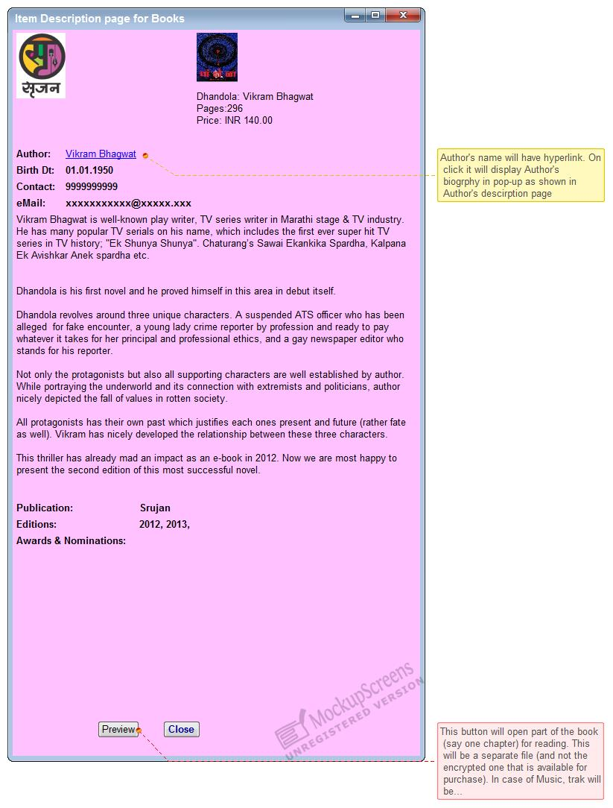

My Shelf
This is an exclusive area of each registered member. This will hold the member’s personal shelf on which all purchased items would be available for member’s use.

This page will display all items purchased by members. These items would be displayed in tabular format and sorted on product type (Books, audio-books, Video, etc.)

All items purchased by customer would be part of “My shelf”.
By clicking on any product, selected item will be open in respective viewer / reader (such as eBook reader, eMedia player etc.) in separate tab.

In case member does not have any item in shelf then appropriate message should be displayed (say “You do not have any item. Please browse thru our collection and purchase any item that you like”).

My Library Page
This is also an area of each registered member. This will hold all items that customer has lend or rented. The item will be available for member only for specific period. In other word each item will have validity period and the same will be available for member for reading / playing during that period only. Member may lend that item again if he/she wants to. The page should display all books lent / rent for reading similar to “My Shelf”

This section may be merged with “My Shelf”. However, clear distinction should be provided to separate the “purchased” items and “Lent / Rented” items.

Registration Page
This page will allow user to register himself / herself as a member.

This page will capture necessary information from user such as Full Name, Address, Contact details, email id, Occupation, Professional domain etc. Members email id will be use as user-id and system will allow user to set password with few rules (Min 6 characters, at least one special char and / or numeric etc).

The form will have three buttons – “Submit” “Cancel”, and “Reset”. On click “Submit”, system will save data after necessary validations. In case of error the appropriate message will be displayed and will resume on the same page. On successful submission an appropriate message would be displayed and email will be sent to user with activation link. User will be taken back to Home Page. His membership will be activated only thru the given link.

“Cancel” button will clear the form and user will be taken back to home page.

“Reset” will clear the form and resume on the same page.

Invoice Page
This page will display the bill of purchased items and allow member to drop some items. Please refer Diagram 12D-11 Invoice Page.

All items from the cart will be billed and total bill will be calculated. Initially “Pay” & “Cancel” buttons would be enabled and “Print Invoice” & “email Invoice” buttons should be disabled.

Each item will have “Remove” check box thru which member can remove the item from list before making final payment. The system will recalculate the bill and refresh Invoice page on each removal of item(s).

Further system will accept payment mode (Credit card or Net banking) from member. Based on the option, necessary information regarding Internet banking should be popped-up. On click “Pay” button, system will transfer the control to respective payment gateway provider with necessary details.

“Cancel” button will remove all items from cart; clears the invoice and user will be taken back to Home Page.

On successful payment, the system will resume on “My Shelf” page of user. System should mail the invoice to member’s registered mail id.

If payment is denied for some or other reason appropriate message will be displayed. The system will resume on the same page so user can try again.

All purchased items will be made available on members “My Shelf”.

Diagram 12D-11 Invoice Page

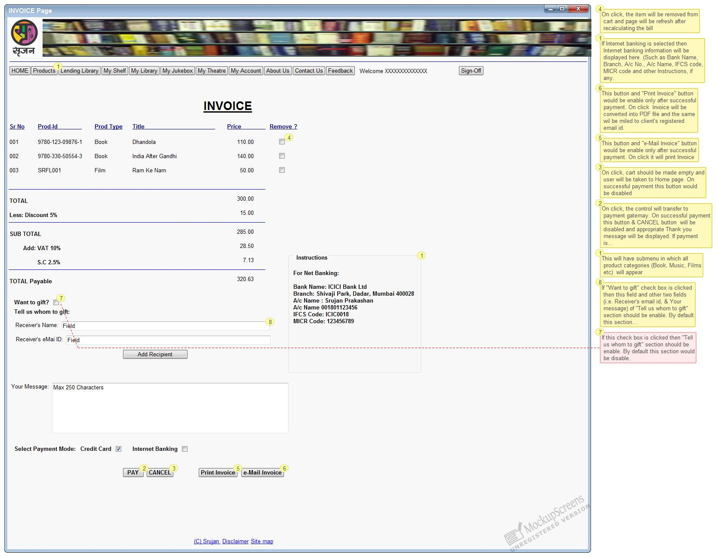

Miscellaneous Functionality
The proposed system should provide following functionality.

Revenue Distribution
Bookworm has adopted revenue distribution model. Hence the revenue from each items will be distributed amongst the all stakeholders of that item. The revenue distribution percentage, its number of stakeholder may vary from category to category and / or product to product.

Bookworm will identify the stakeholders and their percentage for each product.

Please note that author(s) of the book and its stakeholder(s) may be different. Also to be noted that one product may have multiple stakeholders and one stakeholder can be a stakeholder for multiple products.

Revenue (Royalty) will be calculated as follows –

In case of purchase: Royalty will be calculated on base price. Base price is derived by deducting taxes and other charges from Sale price (standard list price). If Bookworm is offering any special discount on any product and selling it below its sale price then still royalty will be calculated on base price. Royalty is calculated based on royalty percentage defined for each stakeholder for that product.

In case of book lent under Library package: In this case royalty will be calculated based on average book cost in package. This cost is derived by dividing package cost by No of books allowed in package. (Ex. Consider example we have taken in chapter “6 Lending Library”. User is allow to take 12 books in this package that cost 120. So average book cost in this package is 120/12 i.e. 10 So royalty will be calculated for the stakeholders of each book selected (lent) by user. And it will be calculated on Rs 10). Please note that royalty will be calculated only if book is lent.

In case of rented books: In this case royalty will be calculated based on total rent.

Please note that stakeholders and royalty percentage is same in case of all three transaction type.

From above description it is very clear that royalty will be calculated immediately after successful transaction in case of purchase and rent transactions. However, in Library it will be calculated only if user select any book to lent.

Excel data upload
The system should provide user to upload product data (Book details) in bulk thru’ Excel. Excel format to enter the data should be provided.

Admin Panel Functionality
It is expected that vendor shall provide necessary interface to update (A/D/C) all tables that are necessary to run the system smoothly.

This is not mandatory requirement.

Point Of Contact

All queries may be sent to Jayant Ponkshe thru mail jayant.Ponkshe@gmail.com or may be discuss in person.

********** This page is kept blank intentionally **********

